1. **Pull the ubuntu latest image:**

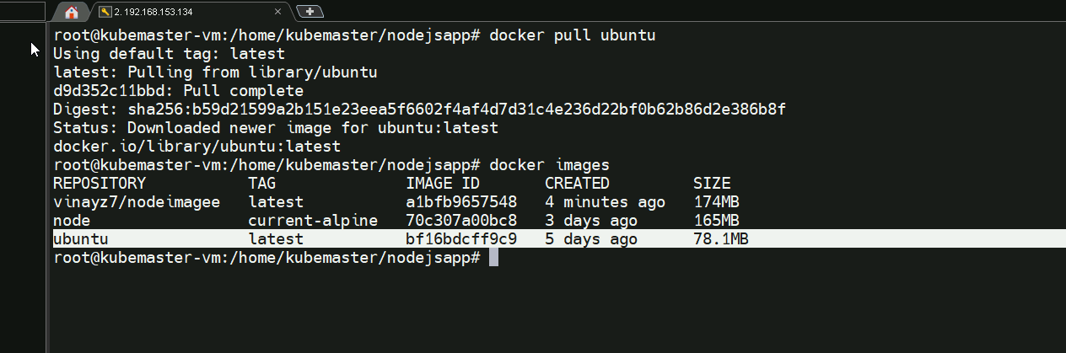

**2,running the container**

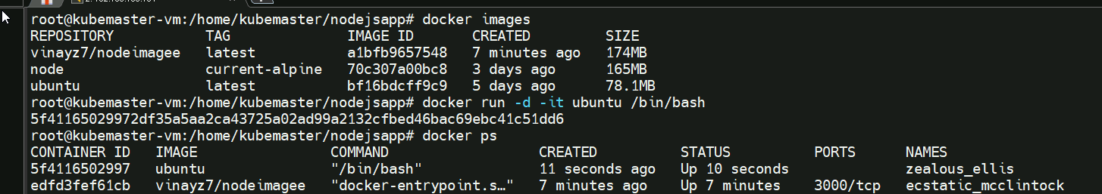

**3,verification of the container system(eg, version)**

**4.stopping**

